EXHIBITOR AGREEMENT
Conditions and Purpose for an Exhibitor/Vendor
Title of CME Activity: |  | Update in IBD 2025 |  | Course Number: |  | RAD26102
Dates: |  | November 8-9, 2025
Course Chair(s): |  | Uma Mahadevan, MD |  | Fernando Velayos, MD
Venue: |  | St. Regis San Francisco- San Francisco, CA
Name of company as you would like it to appear in course materials:
Company (Company Name/Branch):
Contact Person:
Address:
City: |  |  | State: |  | Zip:
Telephone: |  |  | Fax:
Email:

The company listed above wishes to participate as an exhibitor for the above-named activity.
Exhibitor fees are established in the amount of: $4500.00

UCSF is solely responsible for the content and selection displayed by participant exhibitor(s)/vendors at all CME activities. No promotional activities will be permitted in the same room as the educational activity. Exhibitor/Vendor agrees to comply with the AMA, ACPE, CCRN, AAMC and PhRMA guidelines and where applicable, the ACCME Guidelines regarding seminars, meetings and other educational programs.
Exhibitors receive the following benefits:
- (1) 6’ x 30” tabletop exhibit space at UCSF assigned location in exhibit hall
- Standard acknowledgement from the podium
- Acknowledgement in the course syllabus distributed to each registrant*
- (2) complimentary exhibitor attendees and (1) copy of the course syllabus

Commercial supporters are not to conduct marketing or promotional activities in any conference area except for their assigned exhibit space. The exhibitor agrees to abide by the ACCME Standards for Commercial Support of Continuing Medical Education. UCSF agrees to: (1) abide by the ACCME Standards for Commercial Support of Continuing Medical Education; (2) acknowledge support from the exhibitor in program brochures, syllabi, and other course materials, and (3) upon request, furnish the exhibitor a report concerning the expenditure of the funds provided.

Indemnification: University shall defend, indemnify and hold Company, its officers, employees and agents harmless from and against any and all liability, loss, expense (including reasonable attorneys’ fees), or third party claims for injury or damages arising out of the performance of this Agreement but only in proportion to and to the extent such liability, loss, expense, attorneys’ fees, or claims for injury or damages are caused by or result from the negligent or intentional acts or omissions of University, its officers, employees, agents, guests and invitees.

Company shall defend, indemnify and hold University, its officers, employees, agents, guests and invitees harmless from and against any and all liability, loss, expense (including reasonable attorneys’ fees), or third party claims for injury or damages arising out of the performance of this Agreement but only in proportion to and to the extent such liability, loss, expense, attorneys’ fees, or claims for injury or damages are caused by or result from the negligent or intentional acts or omissions of Company, its officers, employees, and agents.

University will in no event be liable to Company or to any third party for any damage to persons or property resulting from any act or omission of any other vendor, contractor, or supplier providing services under this Agreement.

Display fees should be made payable to “UC Regents.” Tax ID# 94-6036493.
Payment must be received by November 6, 2025

UCSF Department of Radiology
Attn: Sean Kirklen
513 Parnassus S257
San Francisco, CA 94143

AGREED:
Company Representative (name):
Title:
Signature: |  |  | Date:
UCSF - CME Representative (name): |  | Sean Kirklen, CMP - Manager of Conference Services
Signature: |  |  | Date:

Exhibitor: Return completed Exhibitor Agreement with your company name, exhibitor fee, and
authorized representative’s name, contact information, and signature to:

UCSF Department of Radiology
Attn: Sean Kirklen
513 Parnassus S257
San Francisco, CA 94143
Email: sean.kirklen@ucsf.edu

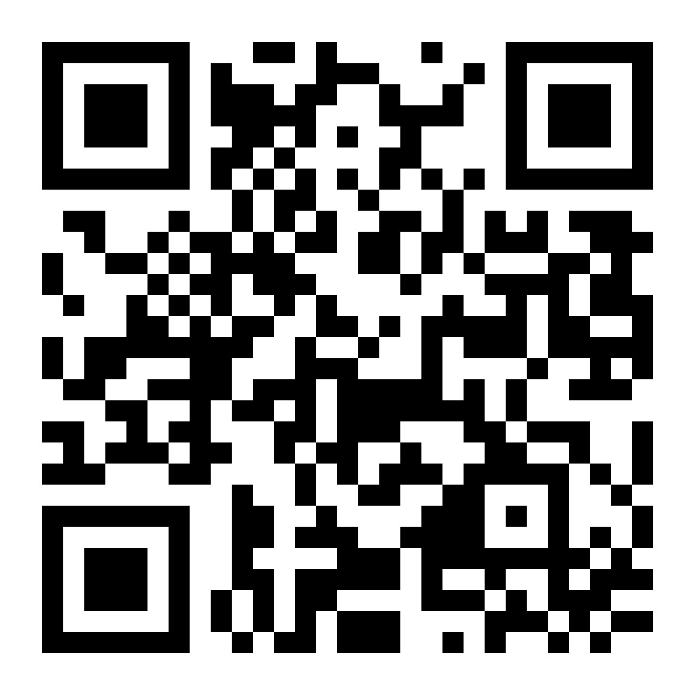
Scan Here for Payment by Credit Card

